Name:B.T.S.AKASH REDDY

Register no: 192111490

Code:CSA0726

**COMPUTER NETWORKS**

21.AAA Local & Server Based Authentication Configuration in Cisco Packet Tracer

step1:-first take switch

step2:-link that switch with pc and after connect it with router

step3:-connect that pc with the switch and the switch to router and router to server

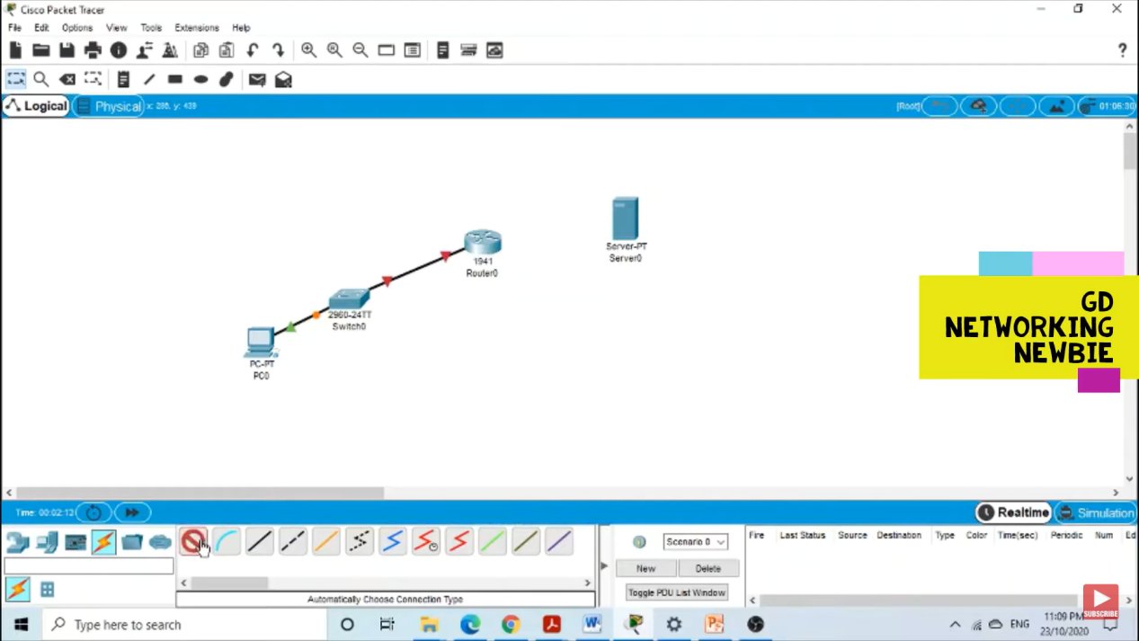

step4:- after connection check the IP address of the all pc in the config

step5:- if command send correctly you got successfull other wise recheck the connections

Step6:- then a AAA Local & Server Based Authentication Configuration was stimulated in packet tracer .

